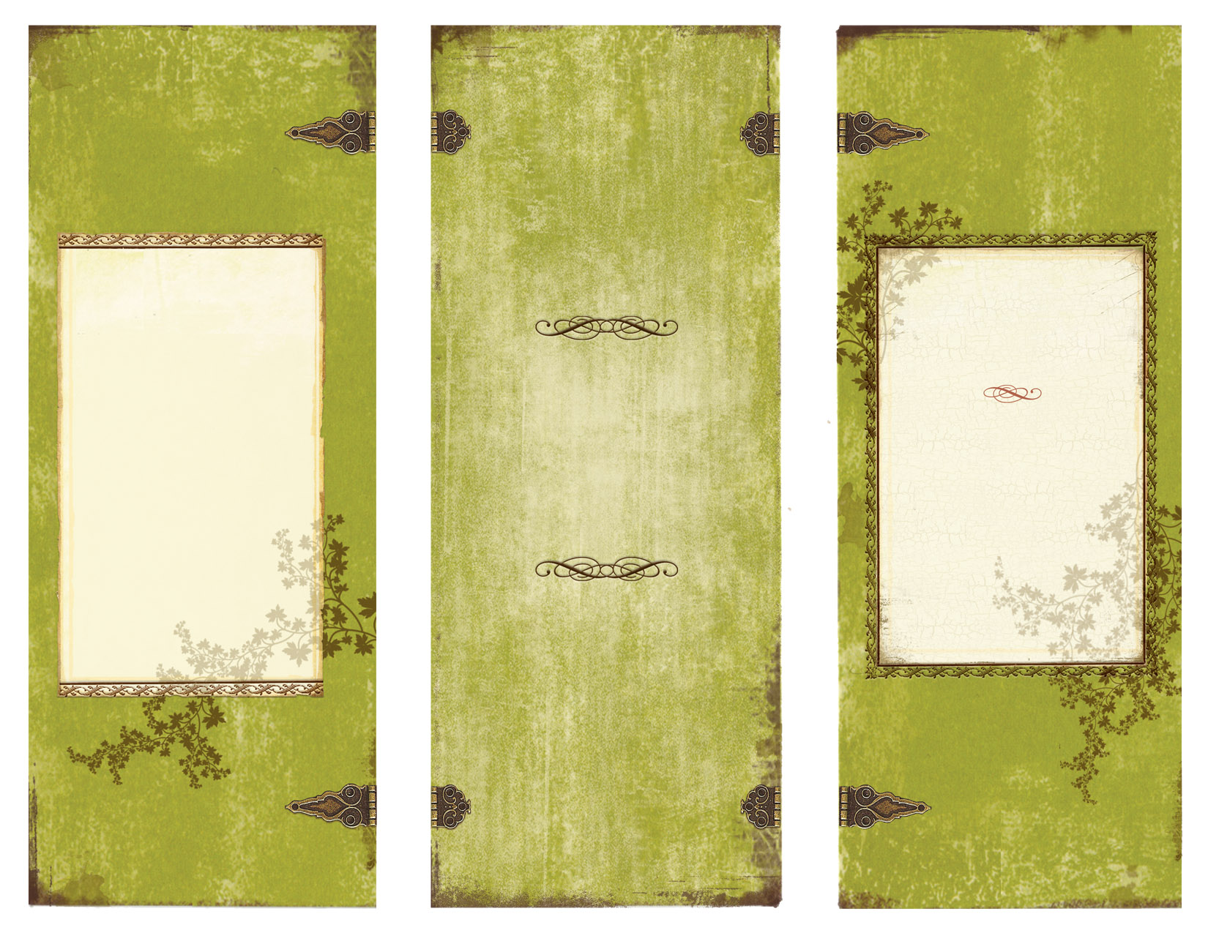

**Georgia College**

**Kilpatrick Education Center Atrium**

231 W. Handcock St.

Milledgeville, GA 31061

Email:

Bill Fisher, GC william.fisher@gcsu.edu

Dr. Doreen Sams, GC Doreen.sams@gcsu.edu

Jeniffer Sams, UF jenfredsams@ufl.edu

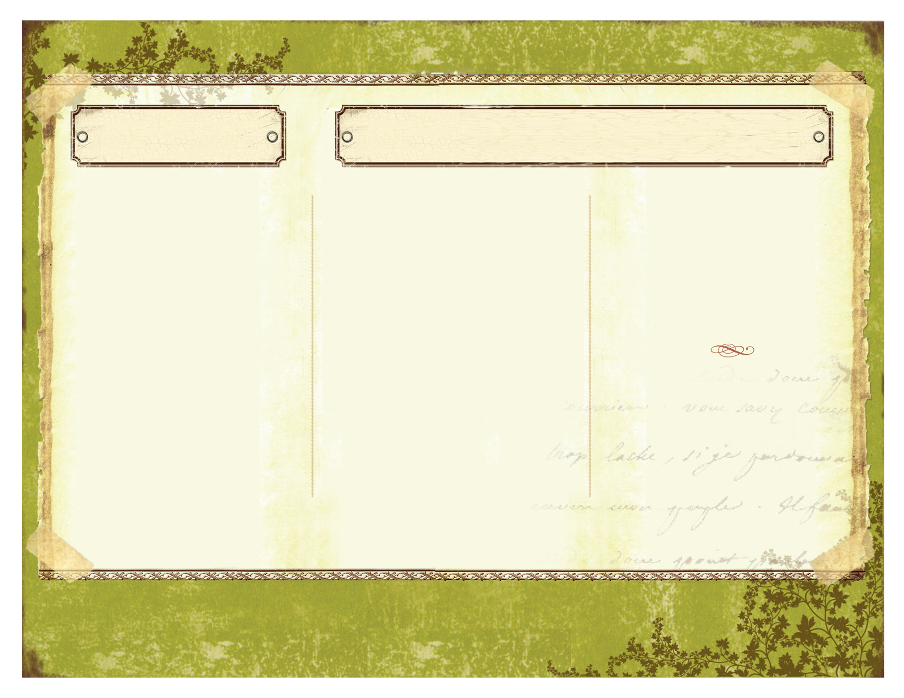

A very special thanks to all our jurors:

Basia Irland, Eco-Artist & Activist

Bill Fisher, GC

Jim Garner, Executive Director,

Lockerly Arboretum

Dr. Sandra Jordon, GC, Provost

Kim Joris, local artist & owner of “The Folks Art”

Dr. Doreen Sams, GC

Jeniffer Sams, UF

“Personal and Global Health: My Role. Our Challenges.”

Top ten high school artists at the exhibition with the three winners announced during the exhibit along with a surprise announcement at the Exhibit for the Student Artists!

ENJOY EARTH DAY 2011 AND HELP BRING AWARENESS TO ENVIRONMENTAL SUSTAINABILITY AND PERSONAL ACTIVITIES WHICH WILL CHANGE THE WORLD… ONE PERSON AT A TIME

**http://greenarted.weebly.com/**

Eco-Art Exhibition

Earth Day 2011

TOP TEN SELECTION

(In alphabetical order)

Venicesia Adams

Candis Anderson

Zachary Bennett

Brittany Butts

Prianna Glover

Norris Johnson

Naomi Jones

Storm Rowland

Devin Simmons

Dominique Tasker

# EARTH DAY AND FALL

# ‘SHADES OF GREEN’ -GEORGIA COLLEGE

**http://greenarted.weebly.com/**

**High School Artists**

*Although this website is about events at Georgia College, Milledgeville, and Georgia Military College, it does not necessarily reflect the opinions of any or all those same organizations. All items are copyrighted.*

**Eco-Art Exhibition – Earth Day, April 22 at 5:00 p.m.**



The idea of combining artwork with information about Earth responsibility and sustainability helps to solidify the ideas of an Earth friendly lifestyle and often serves as a continuous reminder of what the students and the community learn during Earth Day Celebrations and the ‘Shades of Green Week”, Fall 2011 at Georgia College. By connecting Earth Day in the Spring with Shades of Green in the Fall our community is learning new information which carries throughout the year.

“…the arts play a particularly significant role in influencing the attitudes and development of the knowledge that individuals and communities need in order to re-think the position of humans in nature and take action on environmental and sustainability concerns (Meade, 2008).”

“The artist is a receptacle for emotions that come from all over the place; from the sky, from the earth, from a scrap of paper, from a passing shape, from a spider’s web.” Pablo Picasso

“Every child is an artist. The problem is how to remain

an artist once he grows up.” ~ Henry Matisse

“Art owes its origin to Nature herself… this beautiful creation, the world, supplied the first model, while the original teacher was that divine intelligence…” Giorgio Vasari